# **Department of Computer Science and Engineering Islamic University of Technology (IUT)** A subsidiary organ of OIC

# **Lab Report 04**

# CSE 4512: Computer Networks Lab

## 

## **Name :** Abdullah **Student ID :** 200041126 **Section :** 1B **Semester :** WINTER (5th) **Academic Year :** 2022-23

**Date of Submission :** 09-04-2023

### **Title:** Understanding the basics of Variable Length Subnet Mask (VLSM) and VLANs and Inter-VLAN communication

### **Objectives**:

1. Define and describe the concept of VLAN
2. Describe the advantages of VLAN
3. Design and implement Inter-VLAN routing
4. Understand and implement VLSM

### **Diagram of the experiment:**

**TASK #01:**

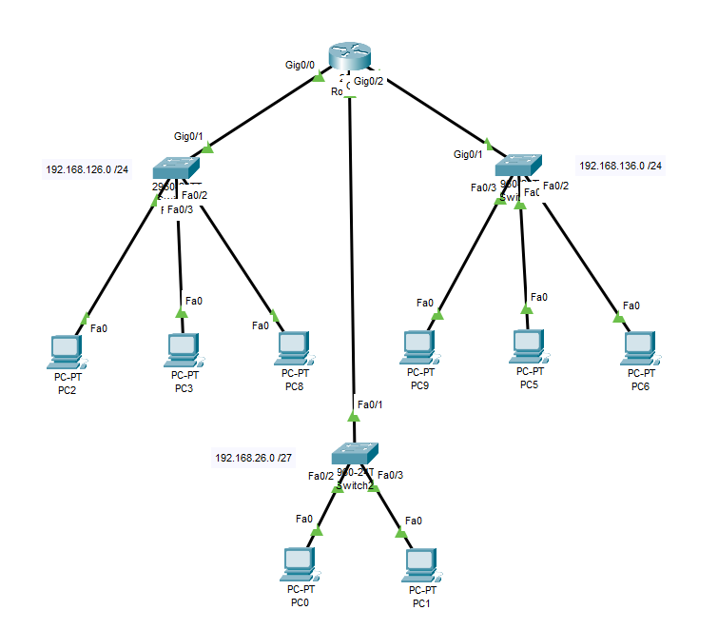

**TASK #02:**

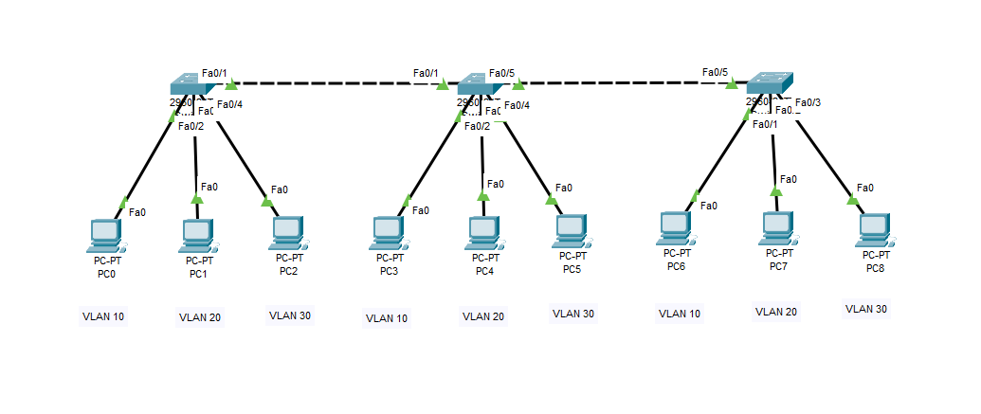

### **Working Procedure:**

**TASK #01:**

My ID is 200041126. Therefore, Y = 26 and I had to assign 26 hosts per network.

As number of assigned host to a network must be a power of 2, I have to assign 32 hosts per network using subnet mask of /27 (255.255.255.224).

So, I assigned proper IP addresses and mask to the PCs connected to that network.

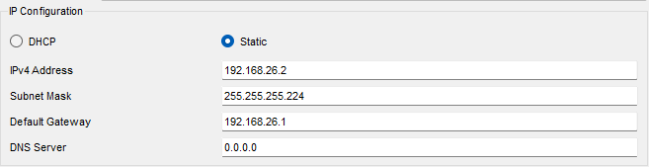

Then, I had to configure the router for the 192.168.26.0 /27 network.

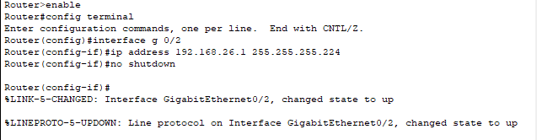

**TASK #02:**

For each Switch, at first, I created 3 VLANs named Students, Teachers and Admin for each Switch using the following commands.

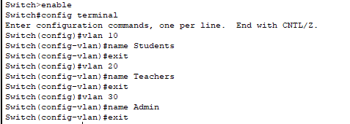

Then, I assigned targeted PCs to specific VLAN by configuring the interfaces connected to each Switch using the following commands for every PC-Switch interfaces.

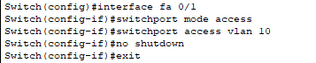

Also, I configured all inter-Switch interfaces so that the VLANs can span over the network through the Switches.

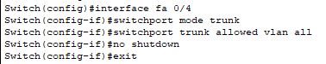

### **Questions (Answer to the point)**:

* + - 1. How many host bits are needed in the largest required subnet?

**Ans:** Last 5 bits are needed to accommodate 32 hosts in the subnet.

* + - 1. How many VLANs need to be configured to each of the switches?

**Ans:** Three VLANs need to be configured for each of the switches – VLAN 10 as Students, VLAN 20 as Teachers and VLAN 30 as Admin.

* + - 1. Which interfaces need Access Link?

**Ans:** All PC-Switch interfaces need Access Link.

* + - 1. Which interfaces need Trunk Link?

**Ans:** All inter-Switch and Router-connecting interfaces need Trunk Link.

* + - 1. After configuring VLAN, what will happen if we broadcast?

**Ans:**After configuring VLAN, if we broadcast only to the devices within the same VLAN as the broadcasting device, they will get the sent packet and for other devices the packet will not be sent. Switch will manage it.